Fiscal Performance Analysis of Capital Receipts (2017–2024)

Project Overview
This project analyzes the fiscal performance of capital receipts over the financial years 2017–2018 to 2024–2025 using data visualization and business intelligence techniques. The study focuses on evaluating revenue trends, growth patterns, and the comparative performance of Budget, Revised, and Actual estimates.
Using Power BI, interactive dashboards were developed to examine year-wise trends, percentage contributions, and Year-over-Year (YoY) growth rates. The analysis aims to identify peak performance periods, revenue fluctuations, and structural shifts in capital receipt composition.
The project provides a comprehensive financial performance assessment to support strategic planning, forecasting accuracy, and improved revenue realization.

Project Objectives
- Analyses Year-wise Financial Trends
To examine the growth pattern of capital receipts from 2017 to 2024 and identify expansion and decline phases.
- Evaluate Budget vs Actual Performance
To assess the gap between projected (Budget), adjusted (Revised), and realized (Actual) capital receipts.
- Measure Year-over-Year Growth
To calculate and interpret YoY growth percentages in order to evaluate financial momentum and stability.
- Study Revenue Structure Composition
To analyze the proportional contribution of different estimate types and identify dependency patterns.
- Develop an Interactive Dashboard
To create a professional Power BI dashboard with KPIs, trend analysis, category comparison, and growth insights.
- Provide Strategic Recommendations
To suggest improvements in forecasting accuracy, revenue realization, and long-term fiscal sustainability.

Data Source

Link: https://indiadataportal.com/p/union-budget/r/mof-ub_capital_receipts-in-yr-aaa

Problem Statement
Capital receipts play a crucial role in determining fiscal strength and long-term financial sustainability. However, fluctuations in revenue, differences between budgeted and actual figures, and variations in year-over-year growth create challenges in evaluating true financial performance.
Between 2017 and 2024, capital receipts have experienced periods of growth and decline. There is a noticeable gap between Budget, Revised, and Actual estimates, making it difficult to assess forecasting accuracy and execution efficiency. Additionally, changes in revenue composition over time raise concerns regarding dependency on projected estimates rather than realized revenue.
Without a structured analytical approach, it becomes challenging to:
- Identify long-term growth trends
- Measure performance stability
- Evaluate gaps between projected and actual receipts
- Detect peak and decline phases
- Support strategic fiscal decision-making
Therefore, this project aims to analyze the fiscal performance of capital receipts using data visualization and business intelligence tools to uncover trends, measure growth, and provide actionable insights for improving forecasting accuracy and financial sustainability.

Attribute

Attribute Name | Data Type | Description
Year | Text / Categorical | Financial year (e.g., 2017–18, 2018–19, etc.) used for trend analysis and time comparison.
Estimate Type | Text / Categorical | Indicates whether the value belongs to Budget Estimate (BE), Revised Estimate (RE), or Actuals.
Capital Receipts Value | Decimal / Currency | The monetary value of capital receipts recorded for the respective year and estimate type.
Growth % (YoY) | Decimal / Percentage | Year-over-Year percentage growth calculated based on previous year's value.
Previous Year Value | Decimal / Currency | Capital receipt value of the immediate previous year (used for growth calculation).
Difference (Budget vs Actual) | Decimal / Currency | Difference between Budget Estimate and Actual value for performance gap analysis.
Contribution % | Decimal / Percentage | Percentage share of each estimate type in the total capital receipts.
Total Capital Receipts | Decimal / Currency | Aggregated total receipts for a particular financial year.

Tools and Technologes
Excel: Data cleaning, transformation, and Pivot Tables.
Power BI: Data modelling, DAX calculations, visualization, and interactive dashboard creation.

Data Pre-processing using Excel
Cleaning steps Performed in Excel
Removed duplicate rows
Handled missing values
Numeric columns → Filled with 0
Standardized text formats
Removed extra spaces
Converted text to Title Case
Created calculated field
Created Total Amount column
Filtered
Removed completely empty rows
Sorted
Sorted by the first column
Created Pivot Table
Sum of amount by Estimate type
Sum of amount by major category
Sum of amount by minor category
Sum of total amount by year
Sum of amount by Subcategory

DAX Calculation and Measures

DAX Calculated column

Year Start Column
Data View → Modeling → New Column
DAX formula: Year_Start = LEFT('Budget'[year],4)
Findings: Shows the staring year of the Budget allocation

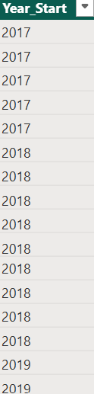
Year End Column
Data View → Modeling → New Column
DAX formula: Year_End = RIGHT('Budget'[year],4)
Findings: Shows the End year of the Budget allocated.
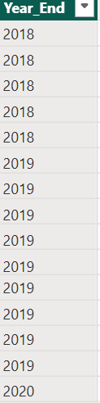

Total by Year
Data View → Modeling → New Column
DAX formula: Year_Total = CALCULATE(SUM('Budget'[id]), ALLEXCEPT('Budget','Budget'[year]))
Findings: Shows the total receipts per year.

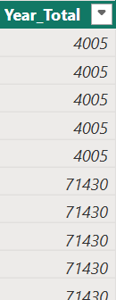
Percentage Contribution
Data View → Modeling → New Column
DAX formula: Percentage_Contribution = DIVIDE( 'Budget'[id], 'Budget'[Year_Total]) * 100
Findings: Shows category % within that year.

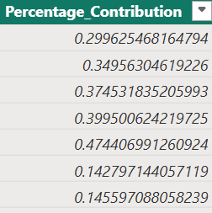

Growth Compared to Previous Year
Data View → Modeling → New Column
DAX formula: Previous_Year_Total = CALCULATE(SUM('Budget'[id]),FILTER( 'Budget','Budget'[Year_Number] = EARLIER('Budget'[Year_Number]) - 1 ))
Findings: shows How much receipts increased or decreased compared to the previous year.

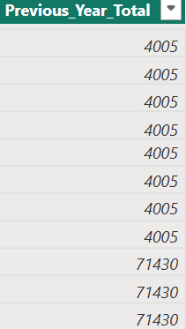

Year-over-Year Growth %
Data View → Modeling → New Column
DAX formula: YoY_Growth_% = DIVIDE( 'Budget'[Year_Total] 'Budget'[Previous_Year_Total],'Budget'[Previous_Year_Total]) * 100
Findings: shows How much receipts increased or decreased compared to the previous year by %
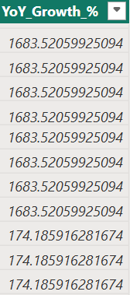

DAX Measures

Total Capital Receipts
Go to → Modeling → New Measure
DAX Formula: Total_Receipts = SUM('Budget'[id])
Shows the total receipts per ID.

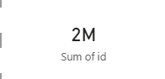

Latest Year Total
Go to → Modeling → New Measure
DAX Formula: Latest_Year_Total = CALCULATE( SUM('Budget'[id]), 'Budget'[year] = MAX('Budget'[year]))
Findings: Identifies the most recent year’s financial performance.



Previous Year Total
Go to → Modeling → New Measure
DAX Formula: Previous_Year_Total =CALCULATE( [Total_Receipts], FILTER(
ALL('Budget'), 'Budget'[Year_Number] = MAX('Budget'[Year_Number]) - 1 ))
Findings: Retrieves financial performance of the year before current year.

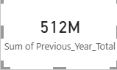

YoY Growth %
Go to → Modeling → New Measure
DAX Formula: YoY_Growth = DIVIDE( [Latest_Year_Total] CALCULATE([Latest_Year_Total], PREVIOUSYEAR('Budget'[year])), CALCULATE([Latest_Year_Total], PREVIOUSYEAR('Budget'[year])))
Findings: Measures annual performance improvement or decline.



Data Visualization using Power BI

CHART VISUALIZATION

Yearly Total Trend
Type of chart used: Line Chart
Findings: Shows overall growth trend.
Visual:
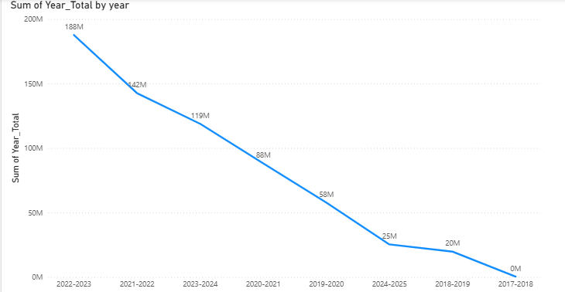

Year vs Estimate Type
Type of chart used: Clustered Column Chart
Findings: Compare Actual, Budget, Revised across years.
Visual:
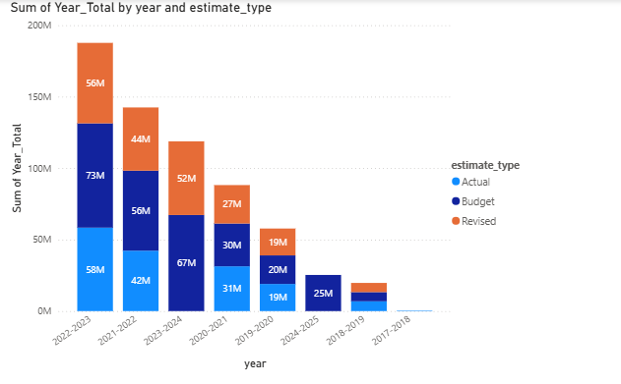

Percentage Contribution
Type of chart used: 100% Stacked Column Chart
Findings: Show percentage share of estimate types per year.
Visual:
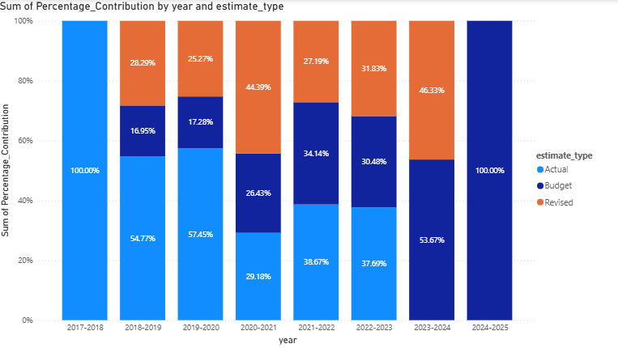

Growth Pattern
Type of chart used: Area Chart
Findings: Track capital receipts across multiple years
Visual:
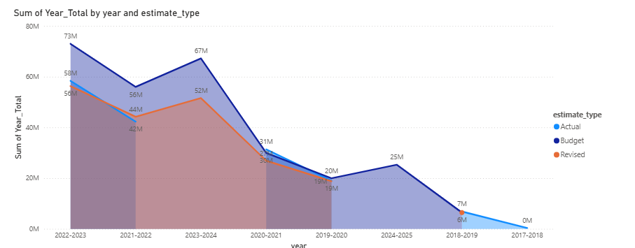

Year-over-Year Growth %
Type of chart used: Line Chart
Findings: Show annual growth rate.
Visual:
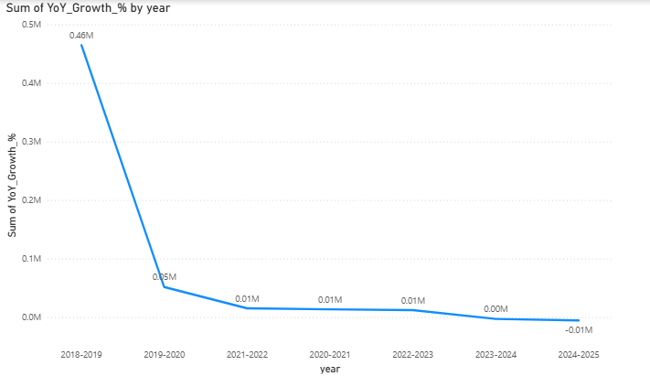
Overall Category Share
Type of chart used: Pie Chart
Findings: Show overall estimate share over the years
Visual:
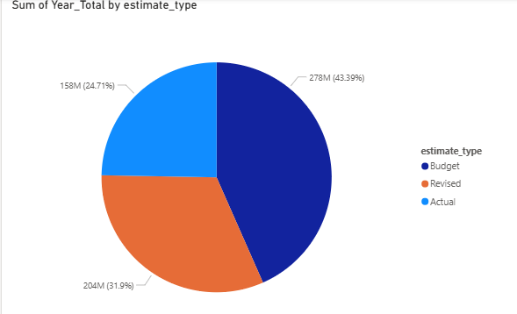

FINAL DASHBOARD

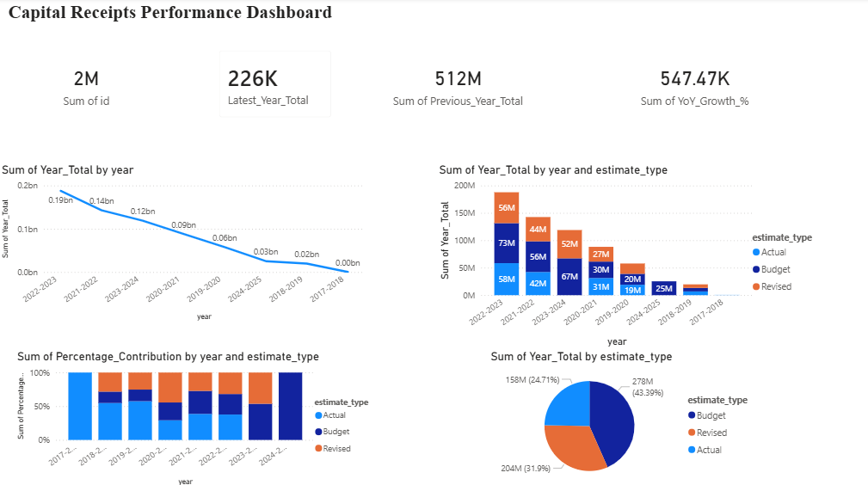

Dashboard Insights

Top Section – KPI Cards
- Total Capital Receipts → Overall financial size
- Latest Year Total → Current performance level
- YoY Growth % → Performance momentum
- Top Contributing Category → Dominant revenue type

Middle Left – Line Chart (Trend Analysis)
- Identifies long-term growth pattern
- Detects peak and decline periods
- Shows financial cycle performance

Middle Right – Clustered Column Chart (Year vs Category)
- Shows which estimate type dominates
- Highlights gap between Budget and Actual
- Detects over-performance or under-performance
- Compares Actual, Budget, and Revised across years.

Bottom Left – 100% Stacked Column Chart (Percentage Contribution)
- Identifies structural changes in revenue mix
- Shows dependency on specific estimate types
- Helps detect imbalance in revenue sources
- Shows relative contribution instead of raw numbers.

Bottom Right – Pie Chart – Overall Category Share
- Planning estimates dominate total capital receipts.
- Actual realization is comparatively lower.
- Possible gap between expected and realized revenue.

Summary, Insights and Recommendations

Summary of Findings
1. Overall Trend
- Capital receipts increased steadily from 2017–2018 to 2022–2023.
- The highest performance was recorded in 2022–2023.
- A noticeable decline is observed in 2023–2024 and further in 2024–2025.
2. Revenue Composition
- Budget estimates form the largest overall share of total capital receipts.
- Revised estimates contribute moderately.
- Actual receipts contribute the smallest portion comparatively.
3. Growth Pattern
- Strong positive growth during the expansion phase (up to 2022–23).
- Growth slowed and turned negative in the most recent years.
- Indicates a possible shift from expansion to stabilization or correction phase.
4. Year-wise Structural Changes
- Percentage contribution of estimate types varies each year.
- The financial structure is dynamic rather than fixed.
- Planning adjustments are frequent.

Key Insights
Insight 1: Peak and Decline Cycle
The dataset clearly shows a financial growth cycle:
- Expansion phase → Peak → Slowdown.
This suggests economic or policy-driven revenue changes.

Insight 2: Budget vs Actual Gap
- Budget values are consistently higher than actual receipts.
- Indicates potential overestimation in planning.
- Suggests improvement needed in revenue realization.

Insight 3: Revenue Volatility
- YoY Growth % fluctuates significantly.
- Indicates unstable growth momentum.
- Financial performance is sensitive to external factors.

Insight 4: High Dependence on Estimates
- A large share of total receipts comes from budgeted projections.
- Heavy reliance on planning rather than actual realization.

Recommendations

1. Improve Forecast Accuracy
- Use historical growth patterns for better estimation.
- Apply predictive modelling techniques.
- Reduce gap between Budget and Actual.

2. Strengthen Actual Revenue Collection
- Improve monitoring mechanisms.
- Enhance execution efficiency.
- Conduct quarterly performance reviews.

3. Monitor Growth Stability
- Implement early warning system for declining trends.
- Track YoY growth regularly.
- Use rolling average analysis for better stability measurement.

4. Balance Financial Structure
- Avoid over-reliance on projected estimates.
- Focus on increasing actual receipts share.
- Maintain sustainable revenue mix.

Final Conclusion

The Capital Receipts dataset reveals a strong growth period culminating in a peak around 2022–2023, followed by a recent slowdown. While budget estimates dominate the overall revenue structure, actual realization remains comparatively lower, indicating scope for improving execution efficiency. Strategic forecasting improvements and stronger revenue monitoring are essential to ensure sustainable financial performance.

